**CYBORG**

**The official Robotics and Automation club of NITR**

**ROBOTIC ARM**

[Motor & Motor Driver]

**NEMA 17 Stepper Motor**

Key Points

|  |  |
| --- | --- |
| Current/phase | 1.7 – 2 |
| No. Of Leads | 4 |
| Step Angle(Degree) | 1.8 ± 5% |
| Holding Torque (kg-cm) | 4.2 |
| Detent Torque(Kg-cm) | --- |
| Roter Inertia(gm-cm2) | 54 |
| Operating Voltage(VDC) | 12 – 24 |
| Resistance(Ω)/phase | 1.6 ± 10% |
| Inductance(mH/Phase) | 3.2 ± 20% |
| Shaft Diameter(mm) | 5 |
| Shaft length(mm) | 21 |
| Diamension(mm) LxWxH | 40x42x42 |
| Weight(gm) | 288 |

Graph of NEM17: Torque v/s Speed

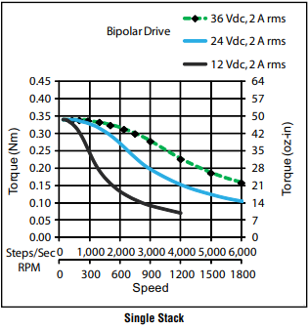

**TMC2209**

Key Points

* 2-phase stepper motors up to 2.8A coil current (peak), 2A RMS
* STEP/DIR Interface with 8, 16, 32 or 64 microstep pin setting Smooth Running 256 microsteps by MicroPlyer™ interpolation
* StealthChop2™ silent motor operation
* SpreadCycle™ highly dynamic motor control chopper
* StallGuard4™ load and stall detection for StealthChop
* CoolStep™ current control for energy savings up to 75%
* Low RDSon, Low Heat-Up LS 170mΩ & HS 170mΩ (typ. at 25°C)
* Voltage Range 4.75… 29V DC
* Low Power Standby to fit standby energy regulations
* Internal Sense Resistor option (no sense resistors required)
* Passive Braking, Freewheeling, and automatic power down
* Single Wire UART & OTP for advanced configuration options
* Integrated Pulse Generator for standalone motion
* Full Protection & Diagnostics
* Compact QFN package with large heat slug